BENCARSON ODHIAMBO
Bencarson Odhiambo

Here is a summary for weekly progress with the project. All the installations the challenges faced are noted here.
CAPSTONE PROJECT
Weekly progress
BBIT/2024/73837
ADVANCED WEB-DESIGN AND DEV.



Table of content. Pages
WEEK 1: Local Environment setup
Installation of XAMPP-------------------------------------------------------------------3
Apache and MySQL running-----------------------------------------------------------3
Localhost Test Page----------------------------------------------------------------------4
Hello world Test---------------------------------------------------------------------------5
Database connection Test--------------------------------------------------------------5
My reflection------------------------------------------------------------------------------5
WEEEK 2: Wireframe and GUI Design
Dashboard Layout Design--------------------------------------------------------------6
Mobile view Mockup--------------------------------------------------------------------7
Color Theme and Navigation Structure---------------------------------------------8
GUI Prototype in Figma-----------------------------------------------------------------9
My reflection------------------------------------------------------------------------------10
WEEK 3: JavaScript and PHP Basics
JavaScript form validation--------------------------------------------------------------11
Password strength checker-------------------------------------------------------------12
PHP syntax practice----------------------------------------------------------------------12
Database connection script------------------------------------------------------------12
Dynamic user input handling----------------------------------------------------------13
Reflection-----------------------------------------------------------------------------------14
WEEK 4:Server-side components and backend development foundations
Understanding sever-side programming---------------------------------------------15
HTML form-----------------------------------------------------------------------------------16
Simple authentication system-----------------------------------------------------------16
Backendfolder Organization------------------------------------------------------------17
Reflection--------------------------------------------------------------------------------18

WEEK 5:Advanced web design and development
Introduction to database-------------------------------------------------------------------19
Database creation----------------------------------------------------------------------------20
Creating tables--------------------------------------------------------------------------------21
CRUD operation------------------------------------------------------------------------------22
Reflection--------------------------------------------------------------------------------------23

http://127.0.0.1:5500/html.project/thumbnails/body.html

Week 1.
Fig 1.1 Apache and MySQL running

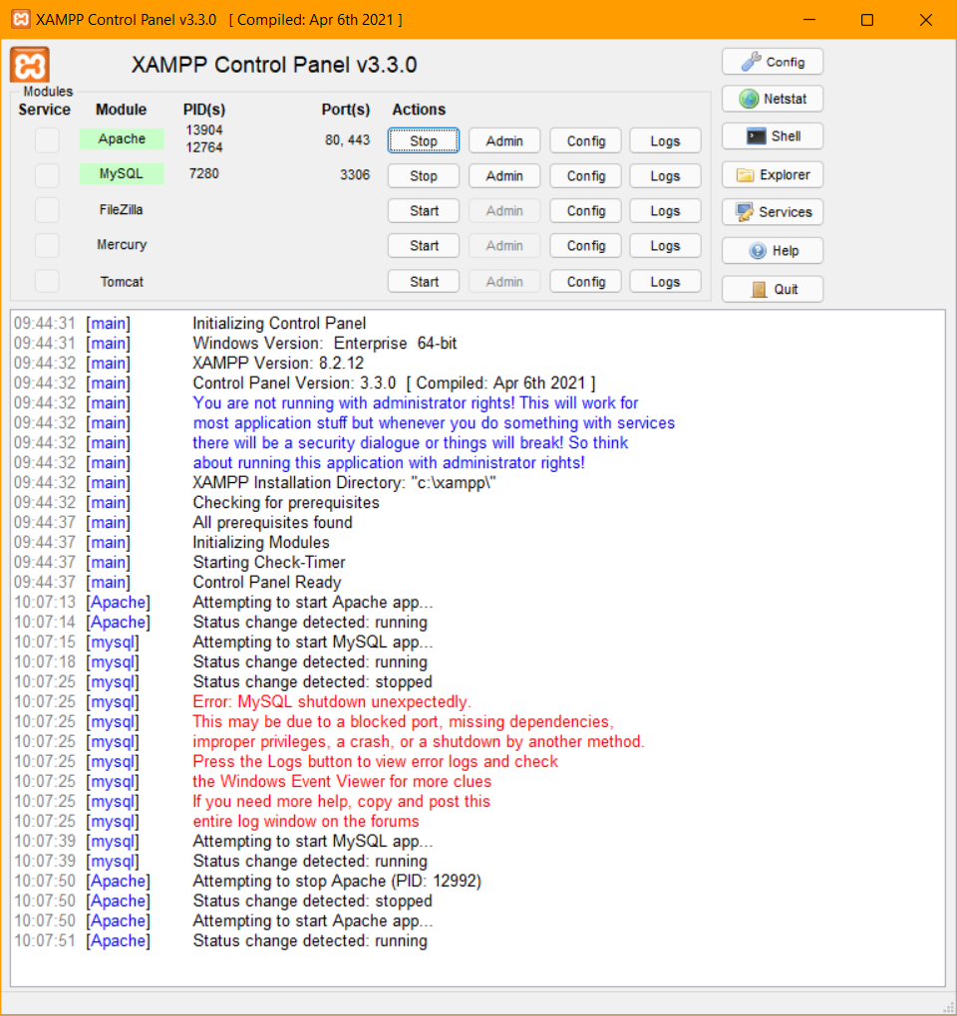

Fig 1.2 Local Host test page
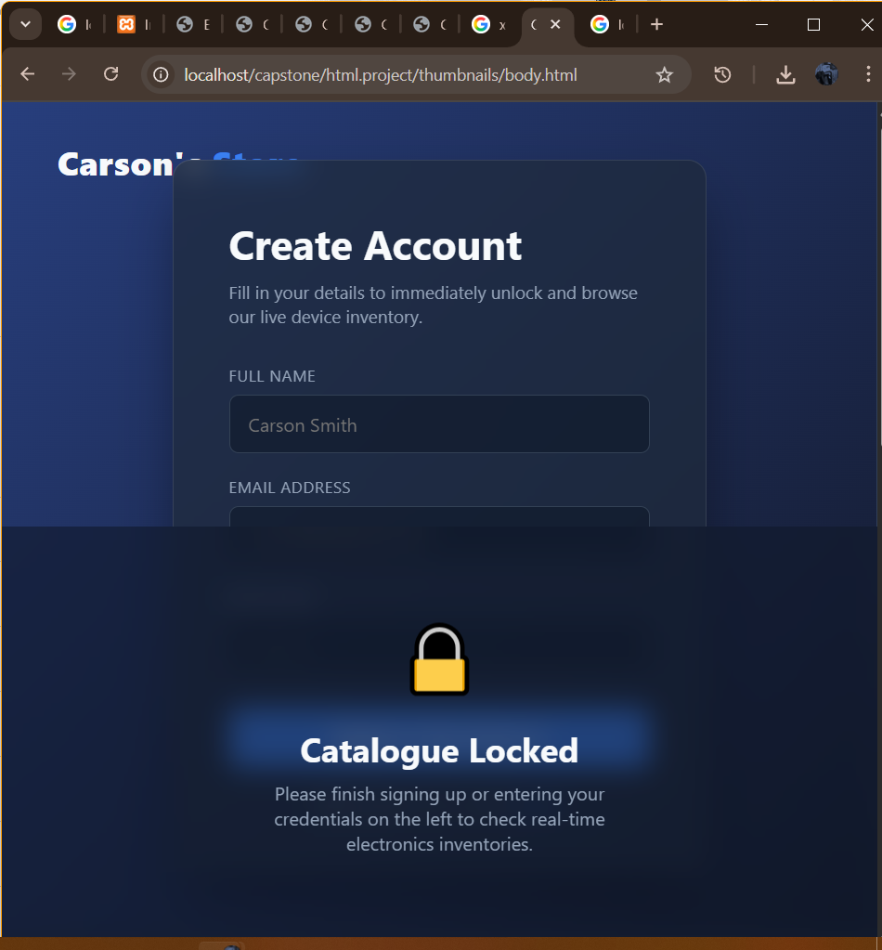

Fig 1.3 Hello world test

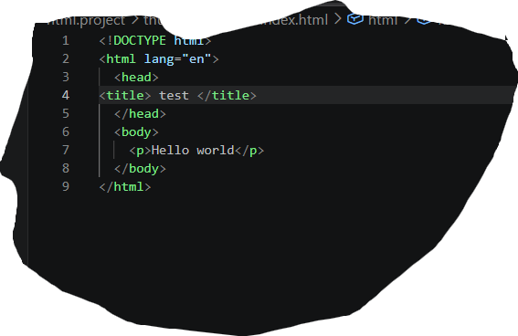

My reflection.
I successfully installed and tested all the required tools, and they are all working well now. However, I did face a few challenges when I initially tried using Apache and MySQL. Fortunately, Visual Studio Code gave me no trouble at all; it worked perfectly and smoothly right from the start. I am glad to have everything up and running properly despite the minor setbacks with the database and server tools. Now that the environment is fully set up, I can comfortably proceed with my development work using Visual studio Code.
WEEK 2. Wireframe and GUI Design

Fig 2.1 Dashboard layout design
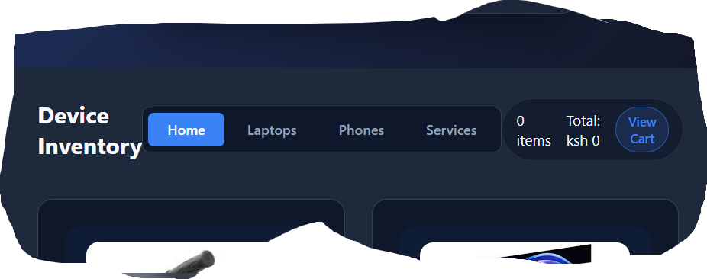

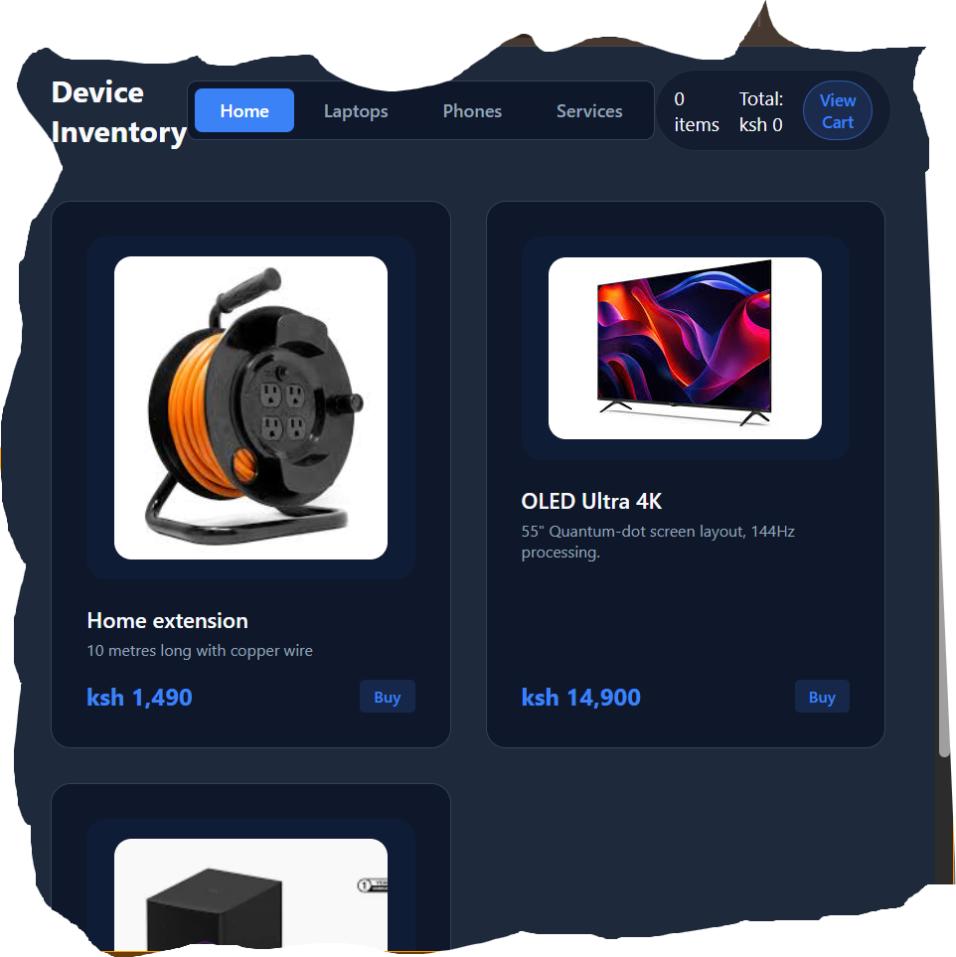
Fig 2.2 Mobile view mockup

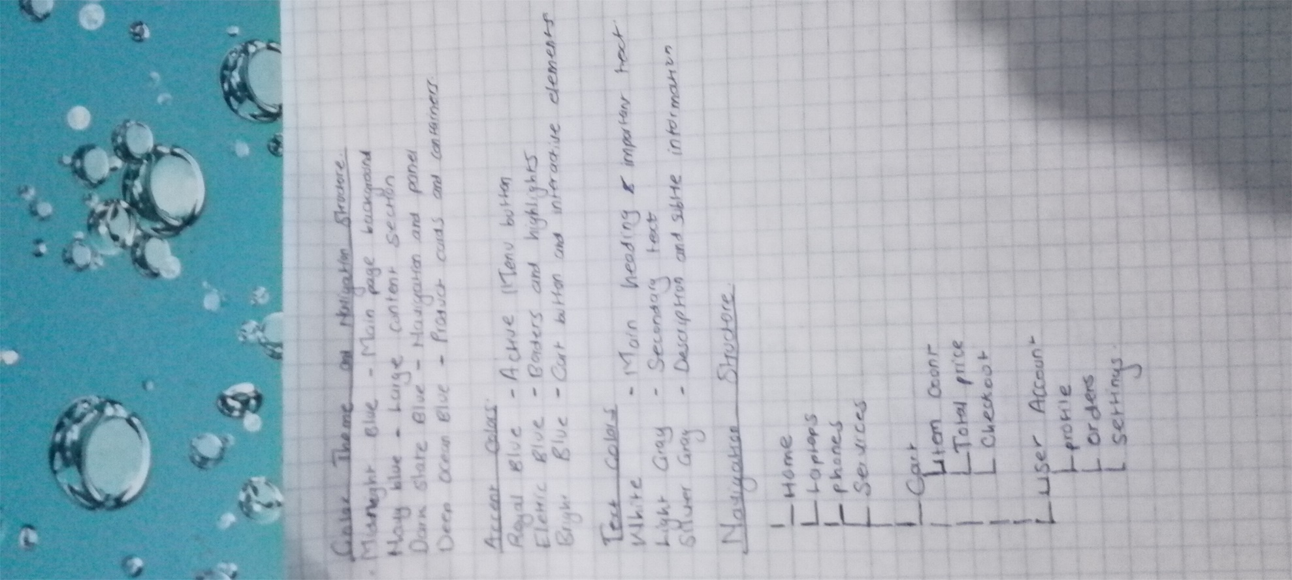
Fig 2.3 Color Theme and Navigation Structure

Fig 2.4 GUI Prototype in Figma
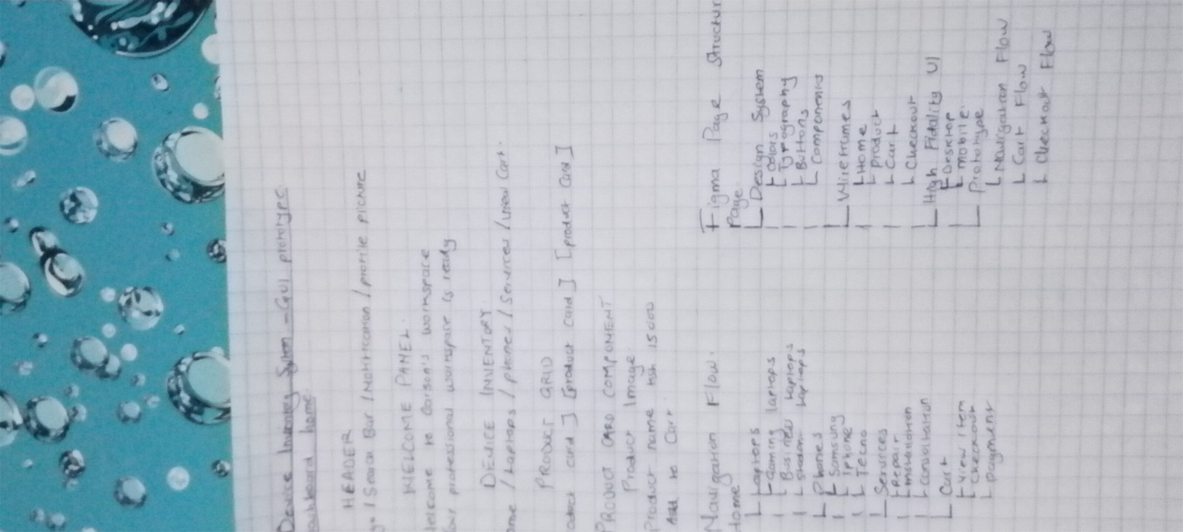

My reflection
The main challenges I faced during the project were designing an attractive user interface, choosing the right colors, organizing the navigation menu, and ensuring all pages worked correctly. I also experienced difficulties in arranging product cards and making the website look professional and easy to use. However, through practice and testing, I was able to improve the system and complete the project successfully.

WEEK 3. JavaScript and PHP Basics

Fig 3.1 JavaScript form validation.

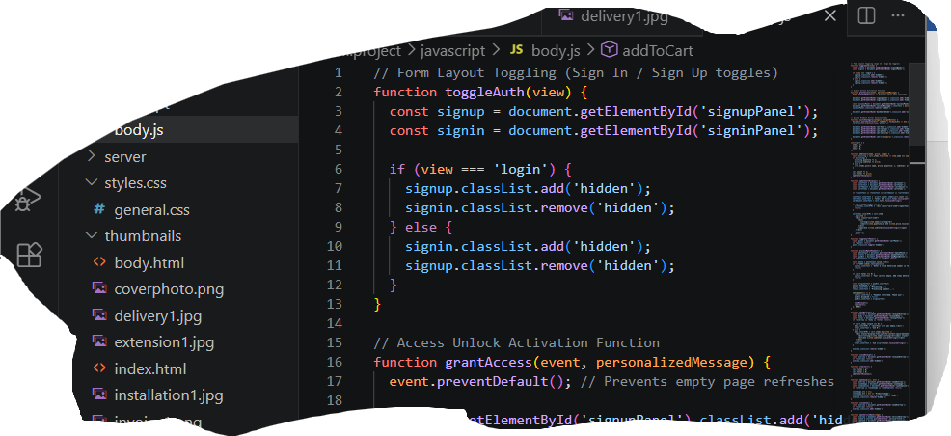

Fig 3.2 Password strength checker
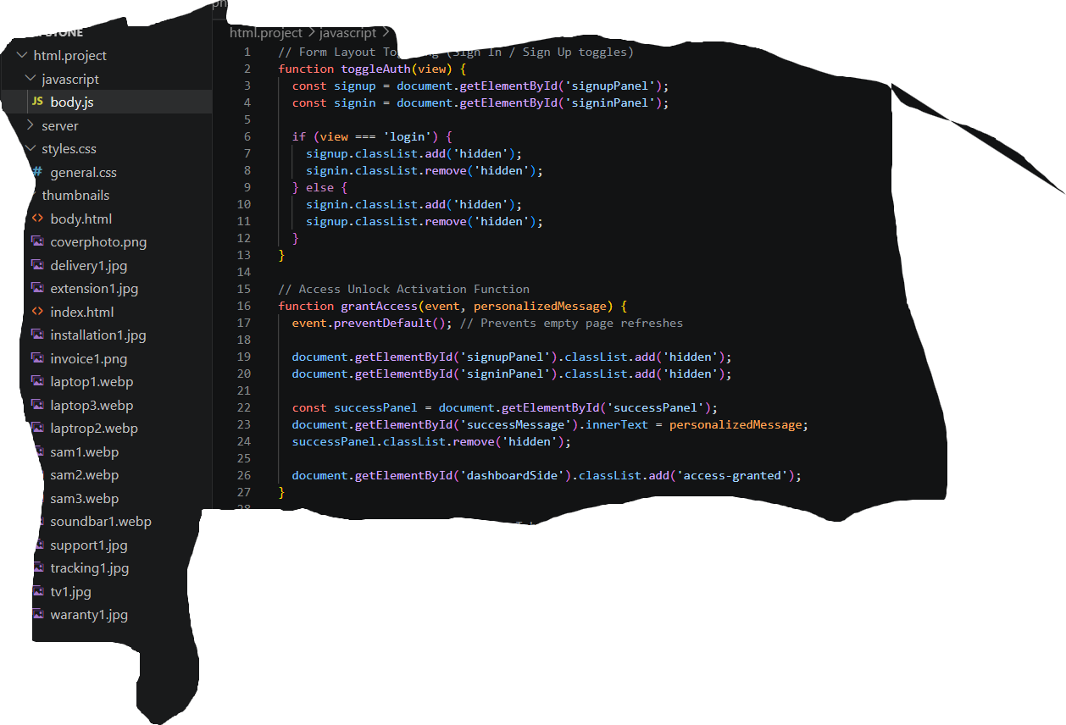

Fig 3.3 PHP syntax practise
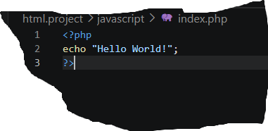

Fig 3.4 Dynamic user input handling

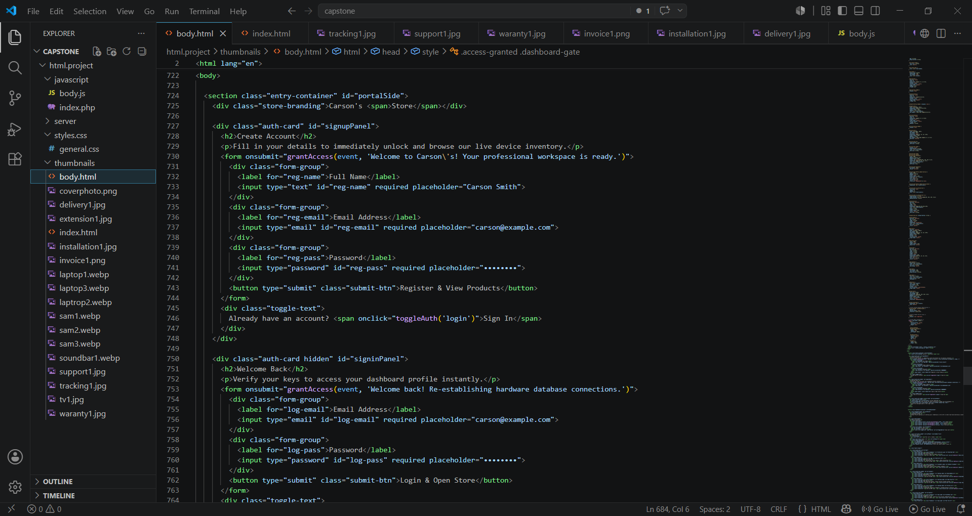

My reflection
During the development of this project, I faced several challenges that tested my technical and problem-solving skills. One of the main challenges was implementing JavaScript functions correctly because some features, such as form validation and dynamic updates, did not work as expected due to coding errors. I solved this by carefully reviewing my code, testing each function, and using the browser console to identify and fix errors. Another challenge was handling user input and ensuring that users entered valid information. To address this, I implemented JavaScript validation techniques and displayed clear error messages. I also experienced difficulties in designing an attractive and responsive user interface. I overcame this challenge by improving the CSS styling, adjusting the layout, and testing the system on different screen sizes until it functioned properly.

WEEK 4.

Fig 4.1 Understanding server-side programming
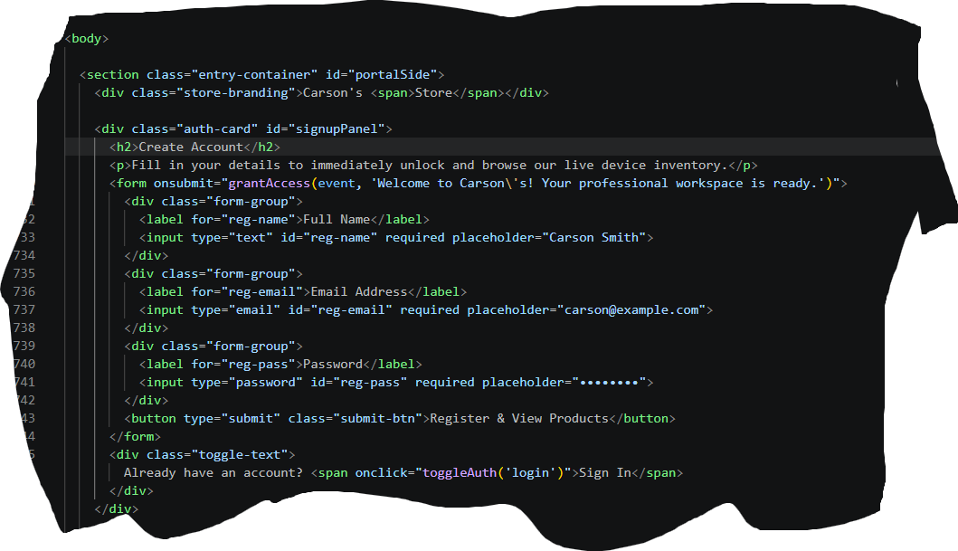
Fig 4.2 HTML forms

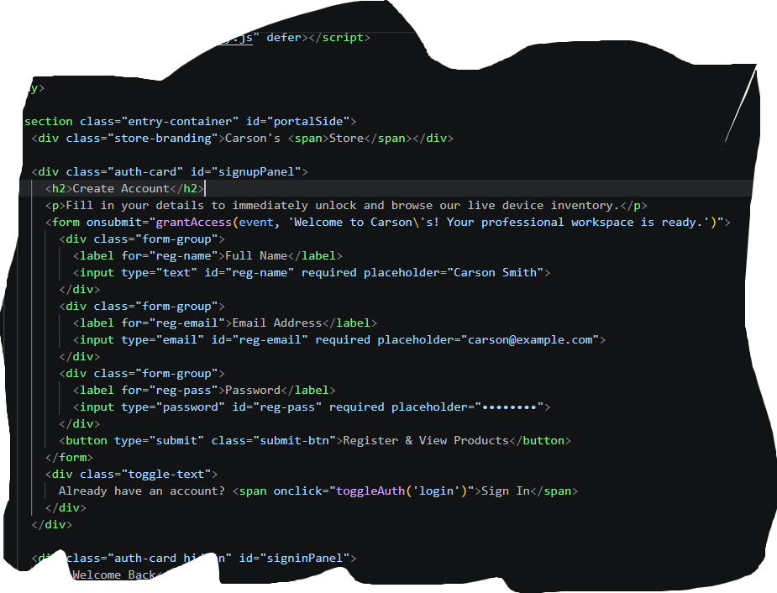
Fig 4.3 Simple authentication system
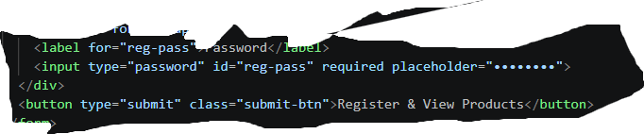

Fig 4.4 Backend Folder Organization

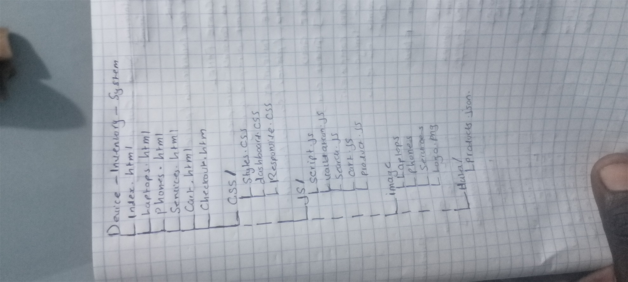
My reflection

I resolve to master backend systems by prioritizing clean code architecture and strict security protocols. Moving forward, I will always utilize industry-standard folder structures like MVC to keep my code maintainable and scannable as project complexity grows. To ensure user data privacy, I commit to never storing plain-text credentials, making robust password hashing with libraries like bcrypt a mandatory step in every authentication system I build. By consistently validating HTML form attributes against my server routes, I will eliminate data-handling errors and build secure, efficient, and scalable web applications.

WEEK 5
Fig 5.1 Introduction to Database

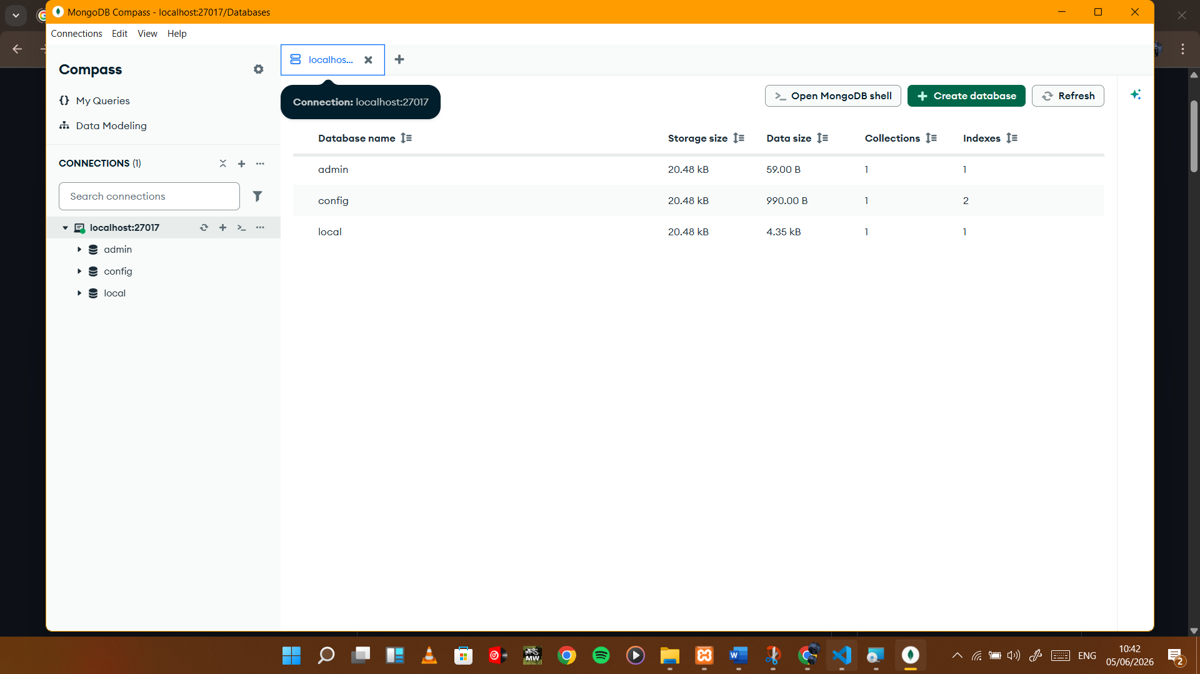

Fig 5.2 Database creation

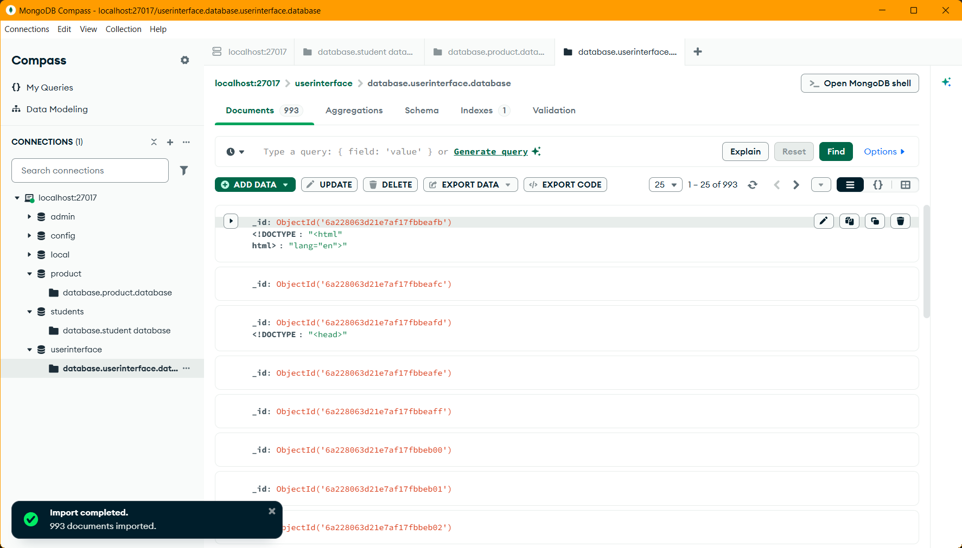

Fig 5.3 Creating Tables

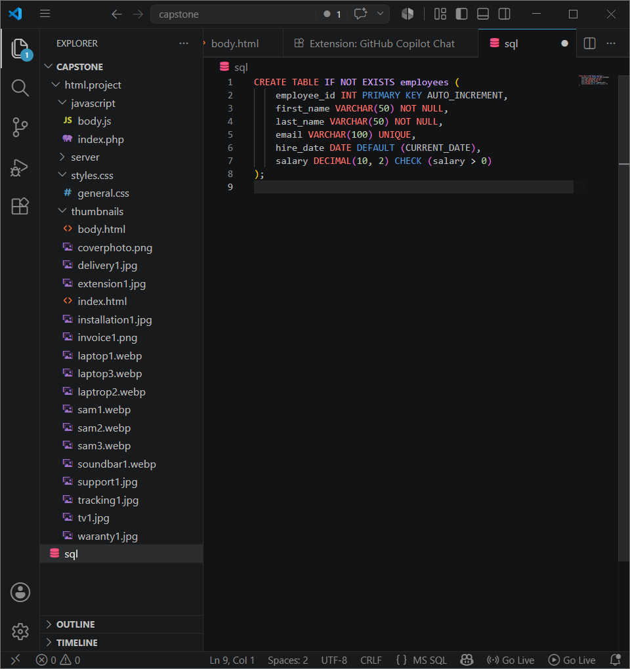

Fig 5.3 CRUD Operation
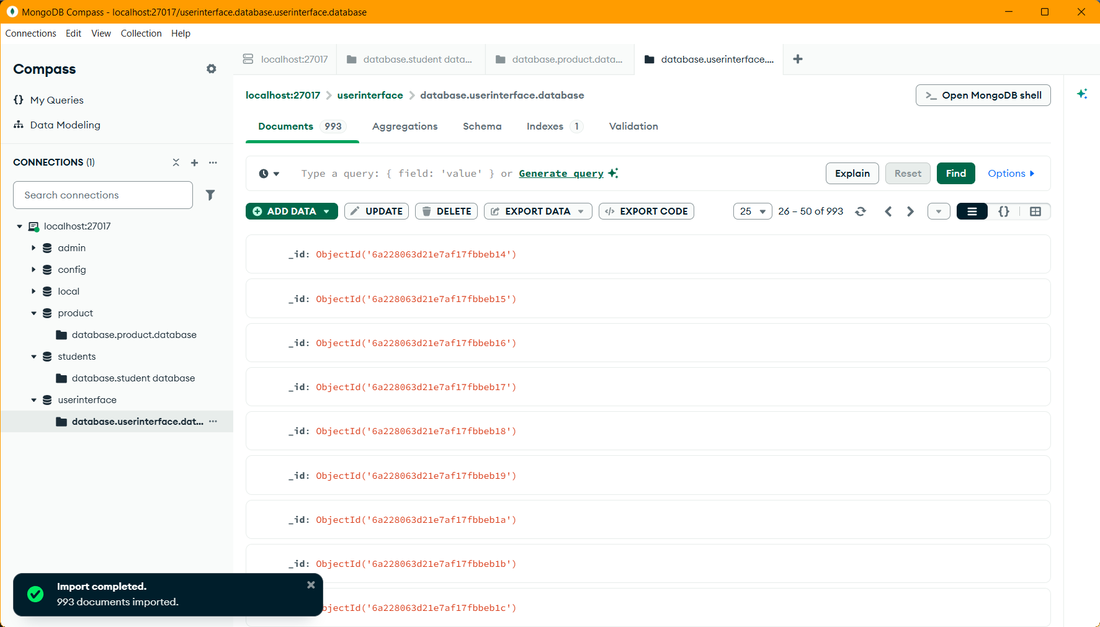

My reflection

Learning database management presented significant challenges, particularly mastering table relationships and executing safe operations. Initially, writing syntax felt overwhelming due to rigid constraint requirements like primary and foreign keys. My biggest hurdle, however, was accidentally executing an command without a clause, which inadvertently modified the entire dataset. I resolved these challenges by adopting a disciplined testing strategy. I began mapping out my schemas visually before writing code. To prevent devastating data loss, I practiced operations inside localized blocks, allowing me to rollback errors safely until my queries were flawless.

